System Modules

User Module

The user has an account on the website and sign in with it in CodeGuide, he get benefit of more features than visitor.

User interacts with CodeGuide through different systems

* Comment system
* Search system
* Post system
* Ask specialist system
* Context Diagram

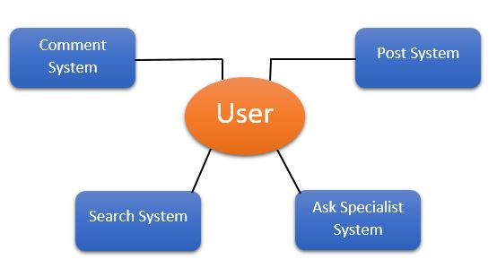

* 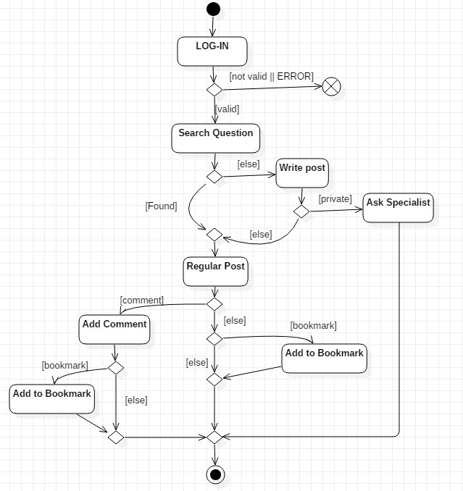Activity Diagram:

Specialist Module

* Signed up in CodeGuide by creating a specialist account.
* Answer questions that are assigned to him by premium users.
* Must provide in his account his technical skills and programming languages which he is expert in it.
* His answers are recorded to inform him of his rate.
* Context Diagram

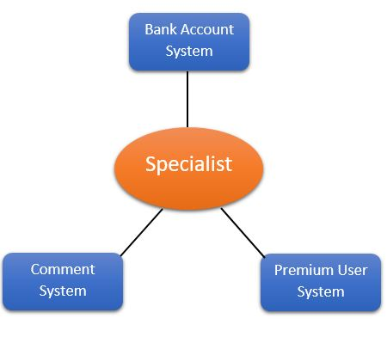

* Activity Diagram:

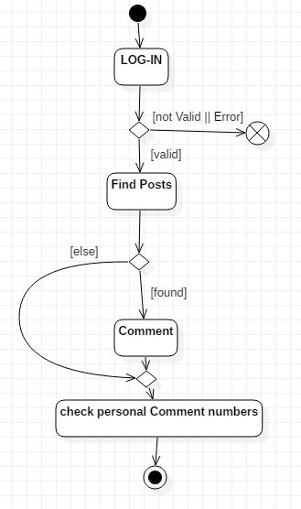

* State Machine Diagram

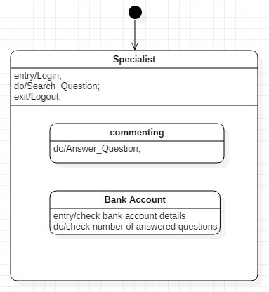

* Data Flow Diagram

